
DESIGN & OPTIMIZATION OF TUBE EXPANSION PARAMETER USING TAGUCHI METHODS
Prepared By:

Supervised By:

Table of Contents

CHAPTER 1. Tube Expansion 3
CHAPTER 2. Parameter from the Tube expansion technique: 4
CHAPTER 3. TAGUCHI TECHNIQUES 6
CHAPTER 4. TUBE EXPANSION NUMERICAL MODELLING 7
References 11

Tube Expansion

As the name suggests, tube expansion is basically the process of eliminating diameter differences between two pipes that are intended to be adjoined from their ends through welding. The end of the tube is expanded with the help of a secondary diaphragm or any extended or experimental part. The basic purpose of this process is to reduce the stress associated with tube contraction or expansion. It is also useful in avoidance of misalignment. Along with prevention of stress corrosion, expansion tube also minimizes the tube sheet distortion, reducing the tension, buckling and bends induced in the process throughout the process. The process is also associated with small tube device that consist on three parts.
Materials in this tube expansions includes an optimal mechanical joint between the tube sheet and tube using a clear process involving the wall reduction percentages where the reduction amount has a variation with tube characteristics, hole diameter and its thickness.
- Higher alloys.
- Copper with abrasive action for tube expanders.
- Stainless steel e.g., titanium.
- Carbon steel e.g., types of pressure vessels.
- Aluminum: 6061-T Aluminum is the most widely used material in the aerospace craft fittings.
The applications of this tube expansion process include;
- Industries; Furniture, Aerospace (Strut assemblies, Helicopter, Elevator).
- Commercial applications; Bicycle attachments, Lightning installments, Bar stools.
- Aluminium & Soft copper tubes used for heat exchangers.
- Condenser tubes.
- Boiler manufacturing for electricity generation.
- Heat Exchanger manufacturing from high-pressure steam generators.

Parameter from the Tube expansion technique:
- Ratio of Extension
- Co-efficient of friction.
- Angle (Mandrel).
- Gauge/Thickness.
- Material composition.
- Friction coefficient
- Extension Ration

Table 1
Parameter | 1 | LEVEL 2 | LEVEL 3
A: Tube diameter- before expansion (d) | 63.5 20 | 76.2 25 | 88.9 30
B: Length (l) | 250 | 300 | 350
C: Ratio of Expansion (r) | 1.1 | 1.25 | 1.333
D: Coefficient of Friction (μ) | 0.05 | 0.1 | 0.15
E: Tube Thickness (t) | 1.5 | 2 | 2.5
F: Mandrel Angle (α) | 20 | 25 | 30

- The expanding of consistent state extension power straightforwardly corresponding to the half-point, which can be changed by the difference in chamber 's width part of the cylinder. Be that as it may, the consistent state development power at first diminished on the grounds that it is conversely relative to the expanding as the half-point is expanded by changing the length of the tightened part of the cylinder, and there is a base to the consistent state extension power when the semi point is in the scope of 11.31 ° - 21.80 °. The expanding of twisting energy is straightforwardly relative to the half point when it is expanded above 15.96 ° by changing the width of the round and hollow piece of the cylinder. Be that as it may, when the half point is under 15.96 °, the plastic deformity energy stays at a generally consistent level.

- The arrangement level of the consumed energy remains basically consistent with various materials' cylinder. Nonetheless, the WM of the development tube is straight with the tractable pressure/power of the first material.

- The consistent state development power, grinding energy, and energy ingestion limit is straightly straightforwardly corresponding with the coefficient of grating. Notwithstanding, the plastic force increments gradually because of the extra shear change

TAGUCHI TECHNIQUES
These are statistics-based quality management techniques introduced by Genichi Taguchi, a renown Japanese Engineer with a keen interest in R & D especially in enhancing the quality of manufactured products through elimination of defects and failures. The end-goal of these techniques was to maintain a quality of production from a very lower cost through the robust-design method.

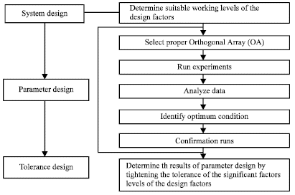

The experimental design of the Taguchi methods involves the structured process that includes objectifying the standard objects in a more measurable and specific manner with the particular target of measuring the performance of operation either set at maximum or minimum values, identifying the process parameters based on variables that have potential of affecting the process which are under control of experiments where there is a need to specify the difference between the level and parameter, developing the orthogonal matrices for design parameters which highlights either the number or condition of every experiment. Thereafter, selecting the matrices on the condition of underlying variances or difference in parameter occurs for the given number where the experiments are defined in this matrix for the gathering of needed information on the performance scale. Finally, the step includes running the data analysis where the influence of each factor comes into play.

TUBE EXPANSION NUMERICAL MODELLING
The quality of tube & shell heat exchangers depends on the reliability of the tubesheet connections and its investigation with the rubber and tube expansions combined with hydralic techniques explains; uniform applied pressure, controllability of the expansion process, reliability and stability considerations. The selection process of these parameters affects the expanding effect & joint quality based on the finding from the Finite Element modelling technique that explains the loading and structure of tubes. This F.E.M simulation verifies the feasibility of the model and its calculations’ accuracy in explaining the various obtained conditions based on deviations from the simulation and those from analytical results.
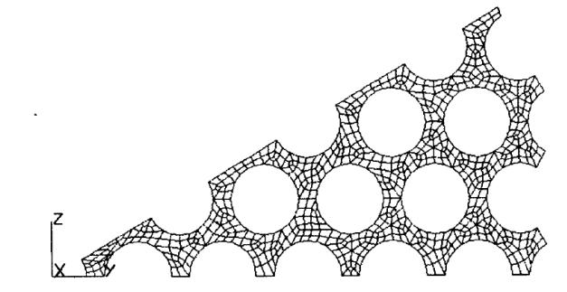
Figure showing the Finite Element Model that shows the triangular-distributed tube holes.
The input mechanical specifications are such that the tube-sheet has; Poisson ratio μ= 0.3, $Yield Stress σ_{s}=220MPa, Young Modulus E=2.1*{10}^{5}MPa$ while the $hole diameters are 0.0254m$, $center distance= 0.032m$, $tube-sheet thickness of 0.050m$.
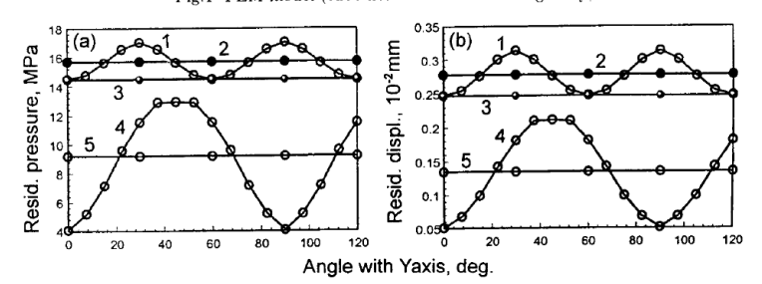
Figure showing the quadrilateral distribution from the Minitab software.
The above figure display the distribution of the displacement and residual contact pressure around the tube holes under similar expansion pressure and tube hold distribution. There is a variation in the displacement and residual contract pressure around the tube holes where they are both low when the rigidity is at its lowest. In the triangular distribution, residual contact pressure occurs in the range between 14.50-17.05MPa with the average value at 15.7MPa that contributes to a relative error equal to 7.77% . The F.E.M model indicates the effectiveness of the residual contact pressure in correction of errors used to account for the practical process of expansion that determines the joint qualities and has a direct implication on the joint’s sealing properties and the pull-out pressures based on the corrective co-efficient

References
Bouzid, A. H., & Zhu, L. (2018). A study of neighboring tube expansion effect on the residual contact pressure of tube-to-tube sheet joints. International Journal of Pressure Vessels and Piping, 165, 185-192.
Kemin, X., Zhen, W., Yan, L., & Kezhi, L. (1997). Elasto-plastic FEM analysis and experimental study of diametral growth in tube spinning. Journal of Materials Processing Technology, 69(1-3), 172-175.
Song, J. L. (2009). FEM numerical simulation of the soft medium tube expansion process. 金属学报英文版, 13(2), 697-701.
Xu, S., & Zhao, Y. (2013). Using FEM to determine the thermo-mechanical stress in tube to tube–sheet joint for the SCC failure analysis. Engineering failure analysis, 34, 24-34.

